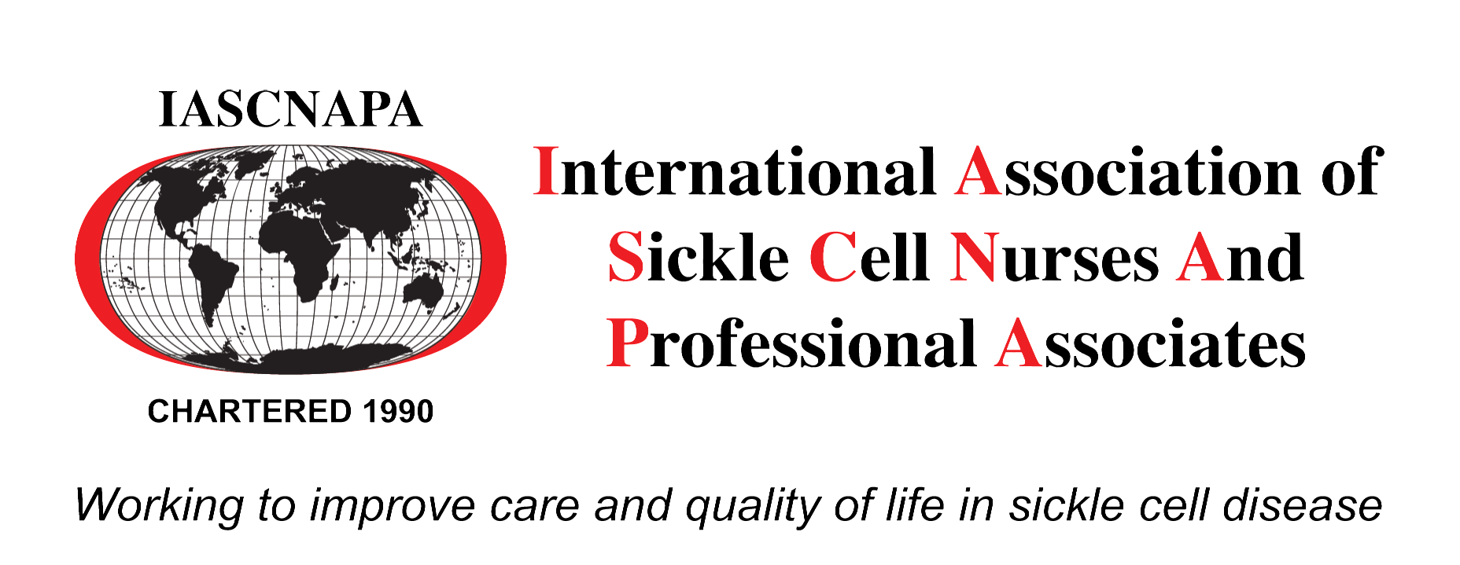
2020 IASCNAPA CONFERENCE SPONSORSHIP FORM
Contact Name: *
Address*
Street:
City: State: Zip:
Email*
Phone:
SPONSOR LEVEL
Platinum ($15,000) – None available
Gold $10,000

Silver $ 7,500

Bronze $ 5,000 *25% discount on Bronze level until 3/17/2020

Advocate $ 3,600

Friend $ 1,200

I am a Platinum, Gold, Silver or Bronze sponsor. I want my logo on the advertisement material and will email my logo to admin@iascnapa.org or yvonne.carroll@stjude.org (In gif, tif or gif) no later than 3/17/2020. Yes No

BAG INSERTS *For Platinum, Gold, Silver and Bronze Sponsors only
Yes Yes, I will mail bag insert by March 17, 2020 to:
IASCNAPA - *Bag Inserts only – NOT PAYMENT ADDRESS
C/O Yvonne Carroll
84 Meredith Cove
Drummonds, TN 38023

No No, I DO NOT want a bag insert

EXHIBITS
Exhibit space will include a 6’ table including draping, 2 chairs, and a wastebasket
Yes I am a Sponsor entitled to a booth and I DO want my exhibit space.

No I am a Sponsor entitled to a booth and DO NOT want my exhibit space.

PROMOTIONAL BOOK ADVERTISEMENTS FOR SPONSORS
Promotional Booklet is an 8 ½ x 11” booklet, a 0.125” bleed from each side of the artwork is required. The artwork must have a minimum resolution of 300dpi.It must be submitted in PDF, TIF, TIFF, INDO, or ZIP. Must be submitted no later than 3/17/2020.
Yes I am a Platinum, Gold or Silver Sponsor and I DO WANT a FREE full-page ad

No I am a Platinum, Gold or Silver Sponsor and I DO NOT WANT a FREE full-page ad

PROMOTIONAL BOOK ADVERTISEMENTS FOR NON-SPONSORS

FULL PAGE AD $1,000
1/2 PAGE AD $ 750
1/4 PAGE AD $ 500
1/8 PAGE AD $ 300

PAYMENT INFORMATION

Make check payable to:

IASCNAPA
c/o Coretta Jenerette
1601 Greene Street
Columbia, SC 29208

Please include the form with payment. For questions, please email admin@iascnapa.org
or yvonne.carroll@stjude.org

